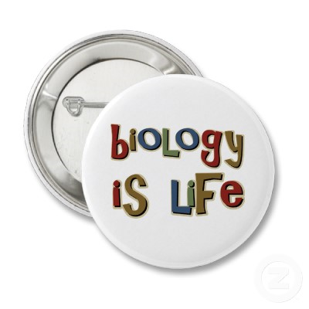**BIOLOGY A**

**COURSE SYLLABUS**

**Instructor: Amie Stover**

**Phone: 506-6253**

**E-mail: amie.stover@anoka.k12.mn.us**

**Office Hours: After School or by appointment**

**COURSE DESCRIPTION:**

This course is designed to introduce the concepts of biology. Students will learn about living things, their life processes, their interactions, and their relationships. Through a variety of activities including lecture, discussion, group work, videos, and hands-on laboratory investigations, students will study ecology, cells, genetics, evolution, plants, and animals.

**MATERIALS:**

You will be prepared for class each day by bringing the following materials: 3 ring binder with lined paper (or notebook and folder to hold papers) and writing utensil (pencil preferred).

**GRADING:**

Grading will be weighted as follows:

Tests/Quizzes: 50% Final Exam: 10% Homework/Labs: 40%

Grade updates will be posted 2 days after each test, in the classroom and on AH Connect. Letter grades will be assigned as follows:

A=90-100% B=80-89% C=70-79% D=60-69% F=below 60%

# PARTICIPATION

Participation in all activities is important to help you learn the material in this class. Students that are absent will have two days to make up any missed assignments, including labs. Labs can be made up before or after school only.

**LATE ASSIGNMENTS:**

Assignments are given full credit if they are turned in at the **start** of class on due date. Assignments only count as being on time if they are fully complete. Late assignments can fall into 3 categories:

1.) 3/4 credit– assignment turned in on due date, but after the start of class.

2.) 1/2 credit– assignment turned in one day late.

3.) 1/4 credit– assignment turned in two or more days late.

* If you are absent, you will have one day to make up an assignment for full credit.

* * 1 day for each day gone.

**BEHAVIOR:**

Because our classroom contains many types of lab equipment, students must follow safety procedures at all times while in the room. You will be asked to report to the office if your actions pose a safety hazard for any other student in the room. You may also be removed from class if your actions are disruptive or distracting other students from their learning. Students caught cheating will receive a zero on that test or assignment.

**ACADEMIC INTERVENTIONS:**

Students are expected to organize their materials and time so that they can keep up with the pace of material and assignments in this class. I will be available before and after school, as well as by e-mail, if you have any questions about assignments or information that we learn in class. Individual plans will be created with all students who are not achieving to help them pass the class.

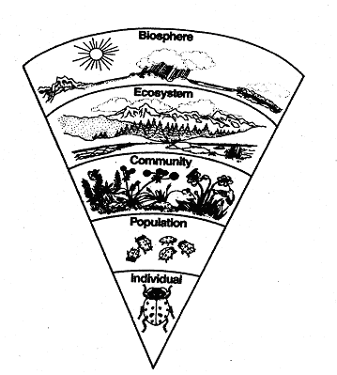

**COURSE OUTLINE:**

* Introduction to biology
  + Characteristics of Life
  + Scientific Method
* Ecology
  + Populations
  + Trophic Levels
  + 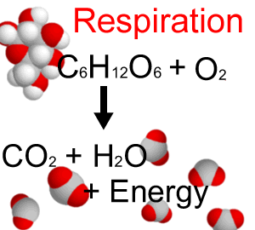Communities
  + Biotic and Abiotic Factors
  + Biomes and Succession
  + Human Impacts on the Environment
* Plants and photosynthesis
  + Basic plant structures
  + Plant responses to the environment
  + Process of photosynthesis
* Cells
  + Chemistry of Living Things
  + 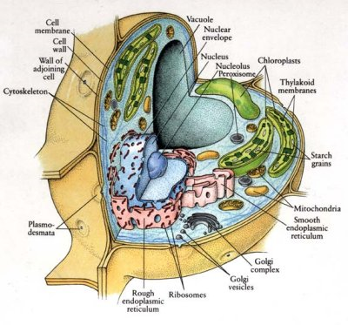Microscope Use
  + Cell Types and Structures
  + Cell Function and Energy Requirements
  + Cell transport

**STOVER’S**

**TIPS FOR SUCCESS:**

1. **BE ON TIME**
2. **COME PREPARED TO WORK**
3. **DO YOUR WORK**
4. **DON’T LOSE IT**
5. **TURN IT IN**